**Project Planning Phase**

**Project Planning Template (Product Backlog, Sprint Planning, Stories, Story points)**

|  |  |
| --- | --- |
| Date | 24 June 2025 |
| Team ID | LTVIP2025TMID55874 |
| Project Name | orderonthego |
| Mentor Name |  |
| Maximum Marks | 5 Marks |

**Product Backlog, Sprint Schedule, and Estimation (4 Marks)**

Use the below template to create product backlog and sprint schedule

| Sprint | Functional Requirement (Epic) | User Story Number | User Story / Task | Story Points | Priority | Team Members |
| --- | --- | --- | --- | --- | --- | --- |
| Sprint-1 | User Authentication | USN-1 | As a user, I can sign up and log in securely. | 3 | High | Bhavani |
| Sprint-1 | User Authentication | USN-2 | As a user, I receive a confirmation email after registering. | 1 | High | Hema |
| Sprint-2 | User Authentication (OAuth) | USN-3 | As a user, I can register/login using Google OAuth. | 2 | Medium | raji |
| Sprint-1 | Login | USN-4 | As a user, I can log into the platform using my email and password. | 1 | Medium | bhavani |
| Sprint-1 | Restaurant Search | USN-5 | As a user, I can view available restaurants filtered by cuisine and location. | 3 | High | Hema |
| Sprint-2 | Order History | USN-6 | As a user, I can view my past orders and track ongoing deliveries. | 2 | Medium | raji |
| Sprint-3 | Menu & Ordering | USN-7 | As a user, I can browse a menu and select items to add to my order. | 2 | High | Bhavani |
| Sprint-3 | Cart Management | USN-8 | As a user, I can review my cart and update items before checkout. | 2 | High | raji |
| Sprint-3 | Checkout & Payment | USN-9 | As a user, I can securely checkout and receive a confirmation email. | 3 | High | Hema |

**Project Tracker, Velocity & Burndown Chart: (4 Marks)**

| **Sprint** | **Total Story Points** | **Duration** | **Sprint Start Date** | **Sprint End Date (Planned)** | **Story Points Completed (as on Planned End Date)** | **Sprint Release Date (Actual)** |
| --- | --- | --- | --- | --- | --- | --- |
| Sprint-1 | 20 | 6 Days | 20 June 2025 | 21 June 2025 | 20 | 21 June 2025 |
| Sprint-2 | 20 | 6 Days | 22 June 2025 | 22 June 2025 | 20 | 22 June 2025 |
| Sprint-3 | 20 | 6 Days | 23 June 2025 | 24 June 2025 | 20 | 24 June 2025 |
| Sprint-4 | 20 | 6 Days | 24 June 2025 | 24 June 2025 | 20 | 24 June 2025 |

**Velocity:**

Imagine we have a 10-day sprint duration, and the velocity of the team is 20 (points per sprint). Let’s calculate the team’s average velocity (AV) per iteration unit (story points per day)

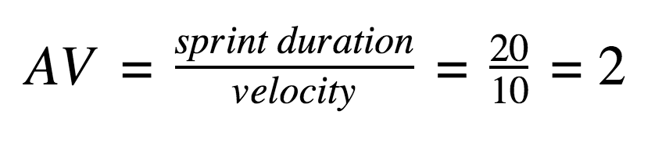

**Burndown Chart:**

A burn down chart is a graphical representation of work left to do versus time. It is often used in agile[software development](https://www.visual-paradigm.com/scrum/what-is-agile-software-development/) methodologies such as [Scrum](https://www.visual-paradigm.com/scrum/scrum-in-3-minutes/). However, burn down charts can be applied to any project containing measurable progress over time.

[**https://www.visual-paradigm.com/scrum/scrum-burndown-chart/**](https://www.visual-paradigm.com/scrum/scrum-burndown-chart/)

[**https://www.atlassian.com/agile/tutorials/burndown-charts**](https://www.atlassian.com/agile/tutorials/burndown-charts)

**Reference:**

[**https://www.atlassian.com/agile/project-management**](https://www.atlassian.com/agile/project-management)

[**https://www.atlassian.com/agile/tutorials/how-to-do-scrum-with-jira-software**](https://www.atlassian.com/agile/tutorials/how-to-do-scrum-with-jira-software)

[**https://www.atlassian.com/agile/tutorials/epics**](https://www.atlassian.com/agile/tutorials/epics)

[**https://www.atlassian.com/agile/tutorials/sprints**](https://www.atlassian.com/agile/tutorials/sprints)

[**https://www.atlassian.com/agile/project-management/estimation**](https://www.atlassian.com/agile/project-management/estimation)

[**https://www.atlassian.com/agile/tutorials/burndown-charts**](https://www.atlassian.com/agile/tutorials/burndown-charts)